**International Jobs 50 Websites**

**Job:1**

**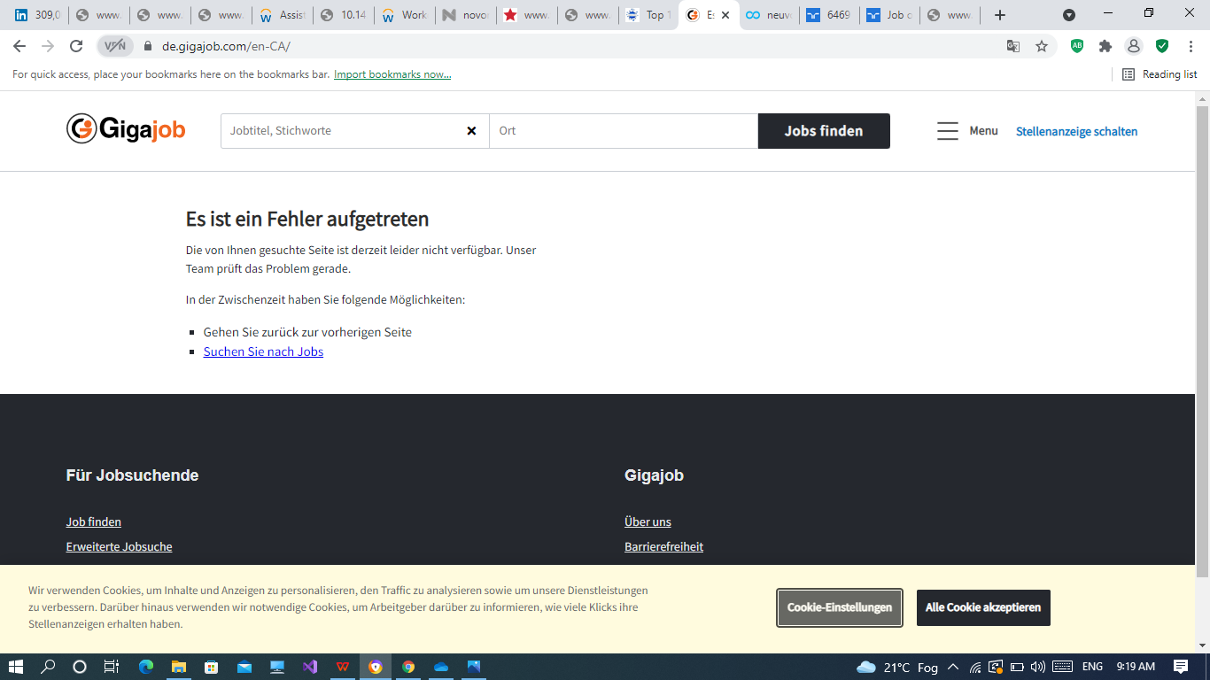**

**URL:**

<https://de.gigajob.com/en-CA/>

**Job:2**

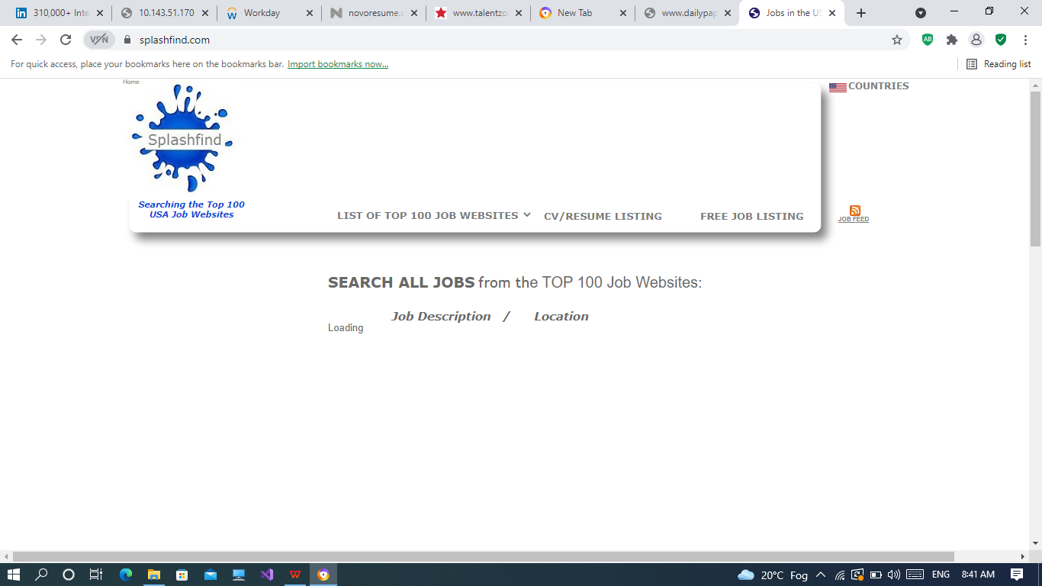

**URL:**

<https://www.splashfind.com/>

**Job:3**

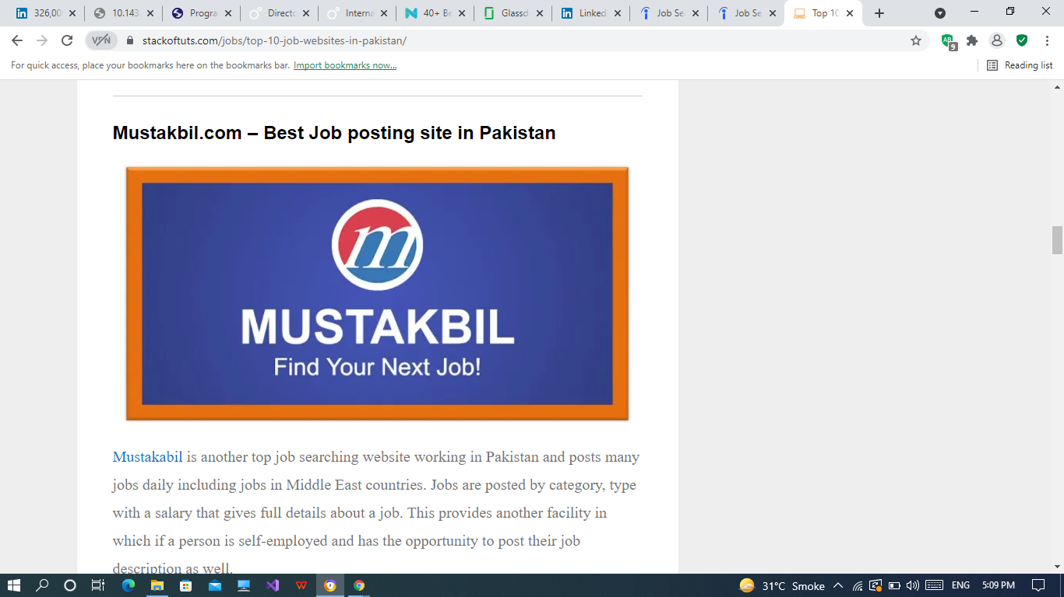

**Job:4**

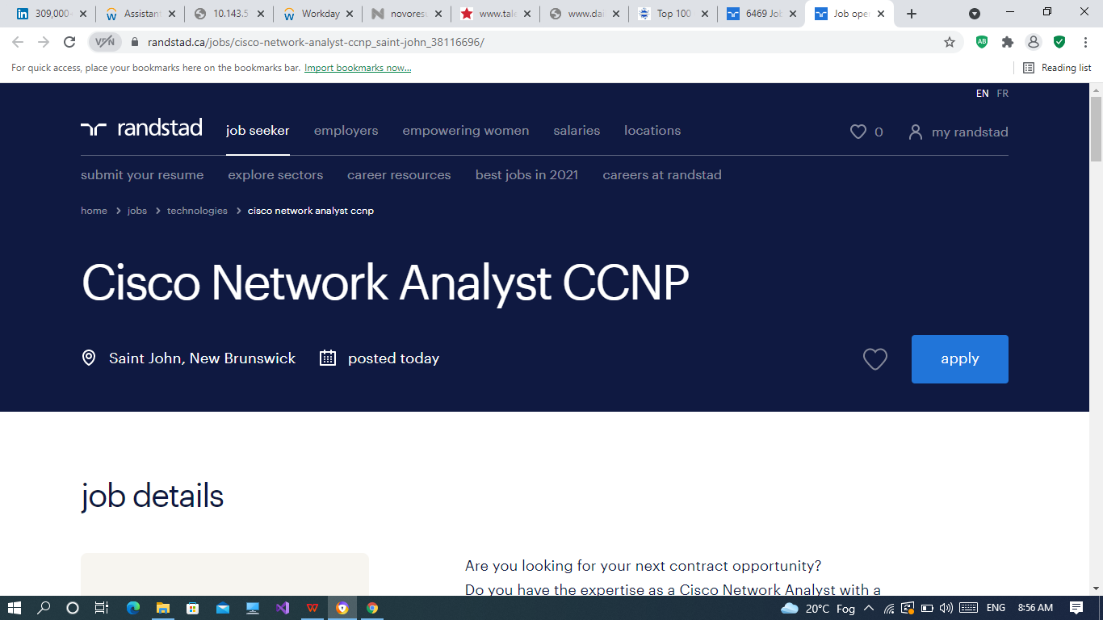

**URL:**

<https://www.randstad.ca/jobs/cisco-network-analyst-ccnp_saint-john_38116696/>

**Job:5**

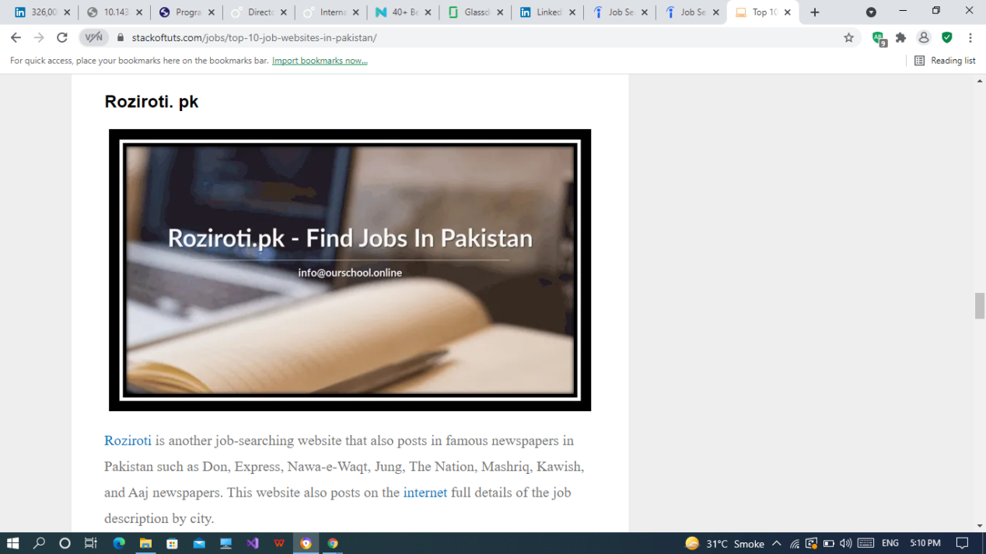

**Job:6**

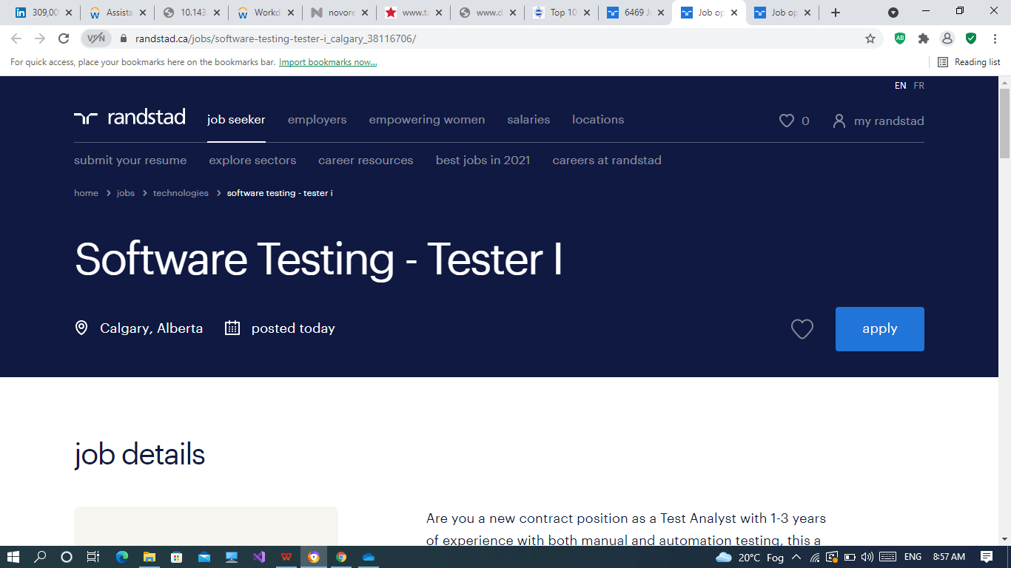

**URL:**

<https://www.randstad.ca/jobs/software-testing-tester-i_calgary_38116706/>

**About Us:**

Are you a new contract position as a Test Analyst with 1-3 years of experience with both manual and automation testing, this a remote contract that can be worked remotely across Canada with a 6 month contract to start, plus a high chance of renewal at a large agile enterprise in the telecommunications industry!

**Job:7**

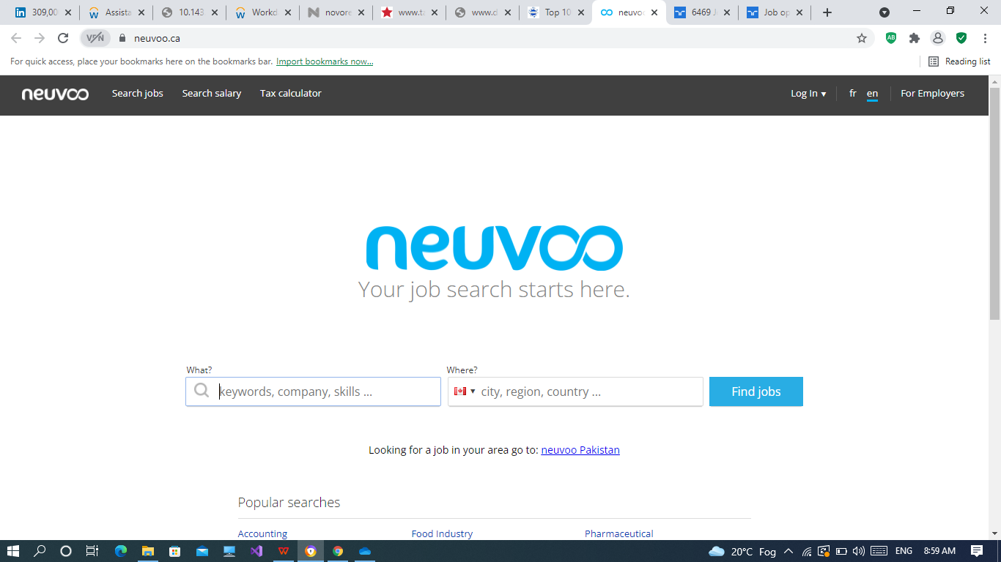

**URL:**

<https://neuvoo.ca/>

**About Us:**

Looking for a job in your area go to: [neuvoo Pakistan](http://neuvoo.com.pk/)

**Job:8**

**URL:**

<https://www.paperpkblog.com/>

**Job:9**

**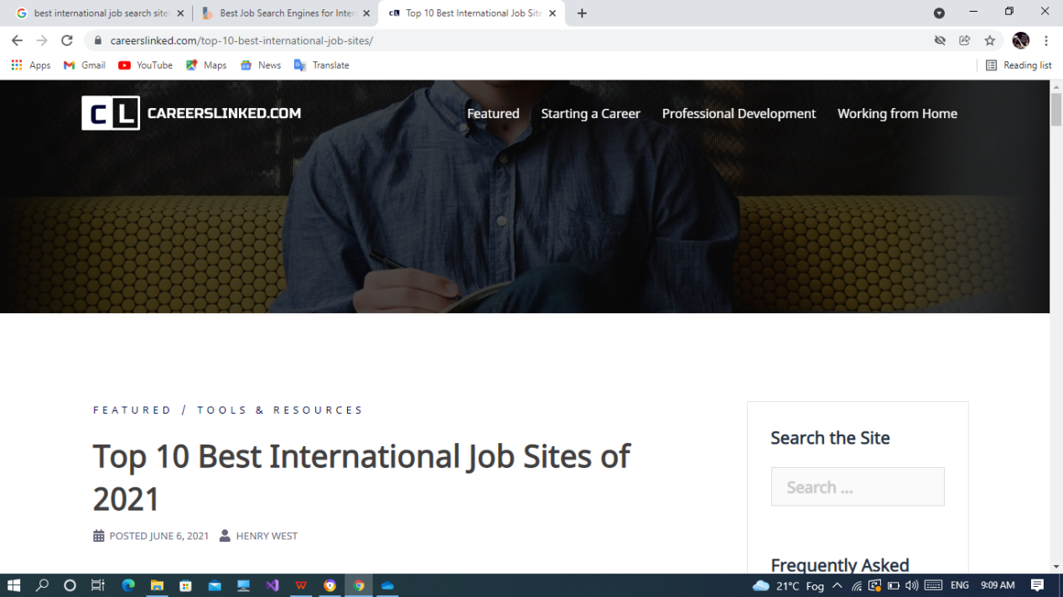**

**URL:**

<https://www.careerslinked.com/top-10-best-international-job-sites/>

**Job:10**

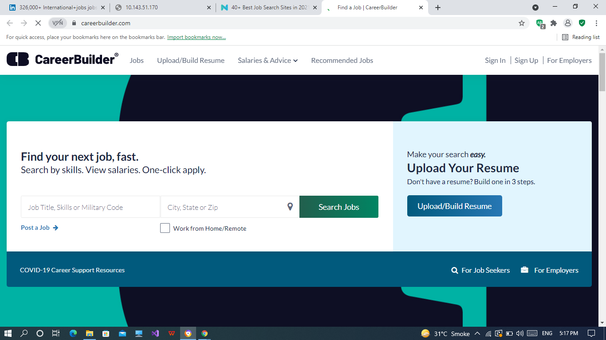

**URL:**

<https://www.careerbuilder.com/>

**About Us:**

[CareerBuilder](https://www.careerbuilder.com/" \t "_blank) makes your job search easy by notifying you of the latest jobs you might be interested in.

The site can give you job recommendations based on your **[resume keywords](https://novoresume.com/career-blog/resume-keywords-how-to-use-them)** and also gives you a **report** of how you compare to other candidates.

**Job:11**

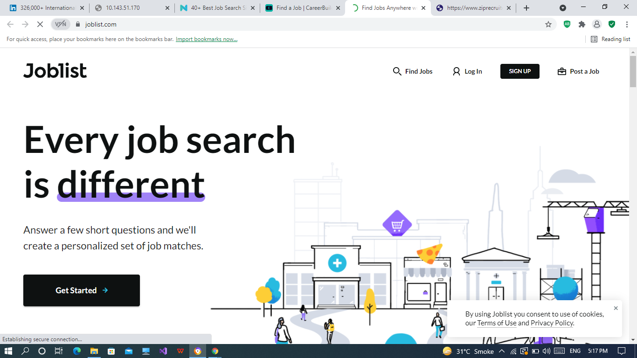

**URL:**

<https://www.joblist.com/>

**About Us:**

[Joblist](https://www.joblist.com/" \t "_blank) boasts well over a **million** job listings in one place.

The UI is **slick**, the search is **instant**, and the results are **relevant**.

It’s simple, and it works great.

**Job:12**

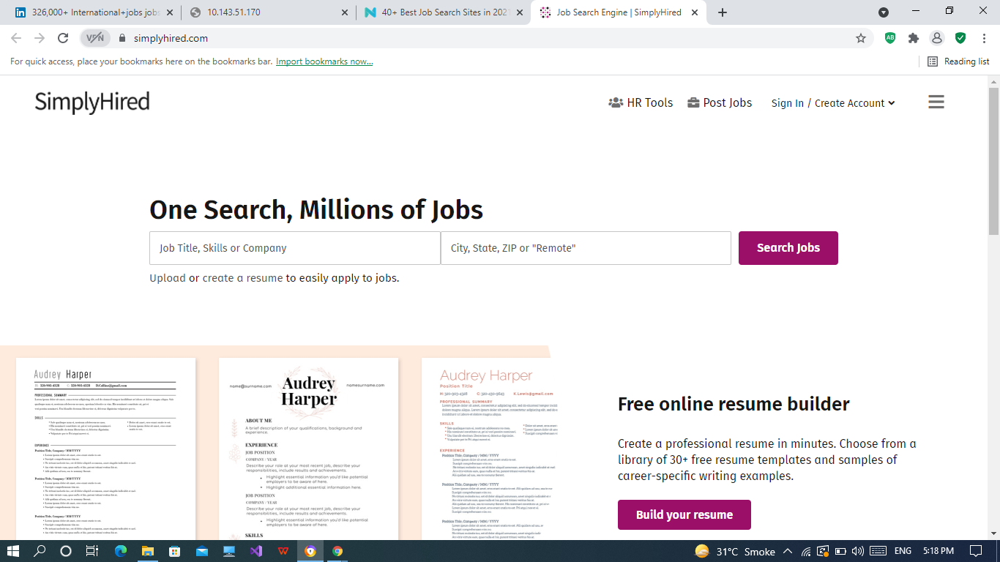

**URL:**

<https://www.simplyhired.com/>

**About Us:**

[SimplyHired](https://www.simplyhired.com/" \t "_blank) is a job search site tailored for you as it allows you to discover **local jobs** and also gives you an approximate **salary estimator** with your job role.

And if you’re not from the United States, don’t worry. SimplyHire also offers several local job listings, depending on your region.

**Job:13**

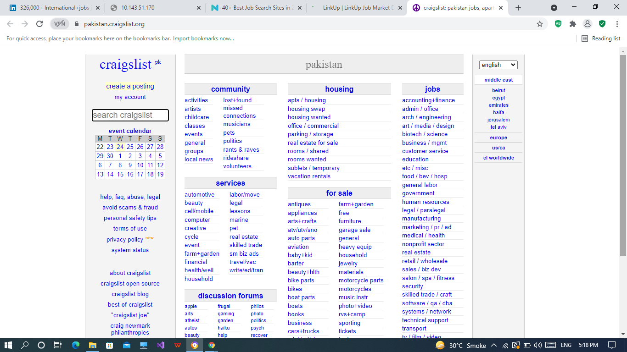

**URL:**

<https://pakistan.craigslist.org/>

**About Us:**

*[Craiglist](http://craiglist.org/" \t "_blank)?! Wait what?*

Yes, believe it or not, Craigslist can be a great job search website because of how straightforward the categories and the listings are on there.

Though you might not find some of the big corporations advertising there, it’s still a great way to find some **local brands**, **small-to-medium** businesses and quick, one-time **gigs**.

**Job:14**

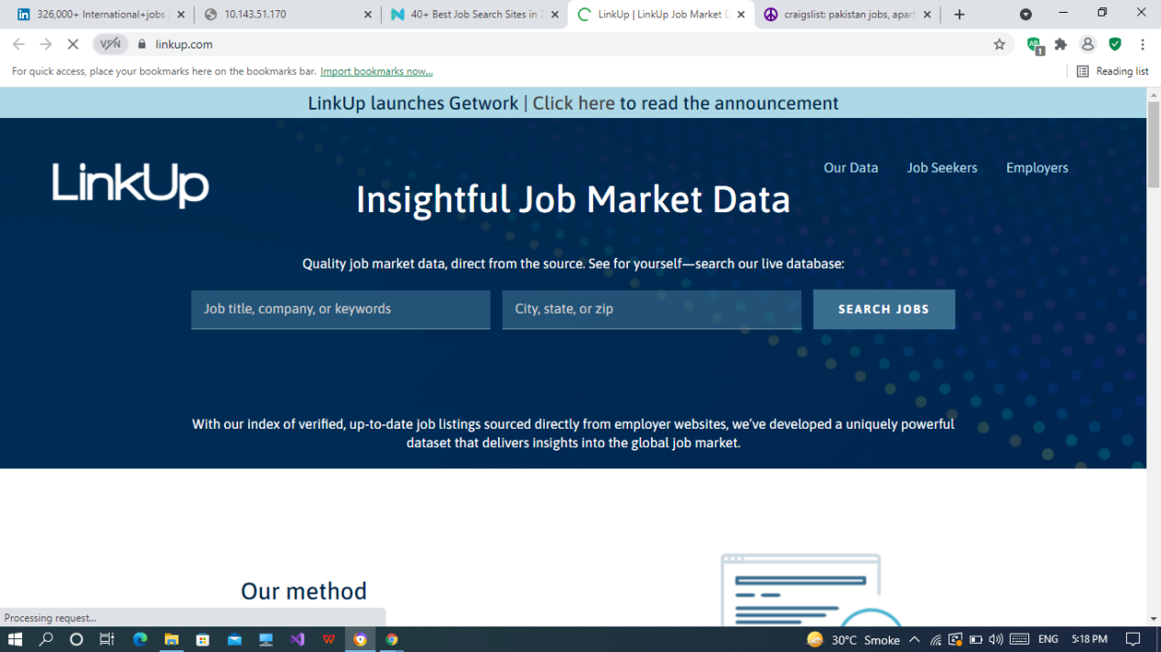

**URL:**

<https://linkup.com/>

**About Us:**

[LinkUp](https://linkup.com/" \t "_blank) is a job search website *and* a data source for job seekers.

They **collect and index** millions of job ads directly from employer websites globally, **process the data**, and then **deliver** insightful and actionable job market information.

For those interested in handling the career data in other ways, they also offer useful data reports, **analytics**, and **indices**.

**Job:15**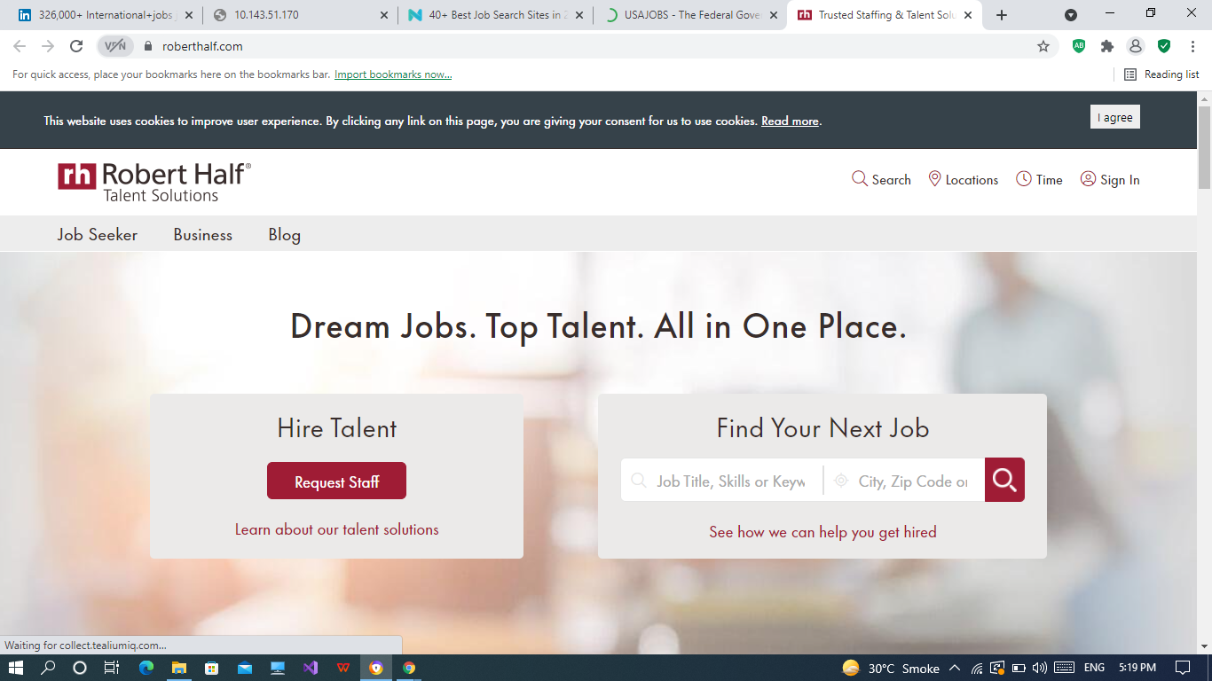

**URL:**

<https://www.roberthalf.com/>

**About Us:**

[RobertHalf](https://www.roberthalf.com/" \t "_blank) is mainly a **job staffing agency**, but it also offers a really solid job search engine.

They work with different companies all over the world, have thousands of listings, and help people find both **full-time** and **part-time** positions.

Though, their areas of specialization don’t end there, as they also offer other HR management **resources** and **solutions** to companies if needed.

*You can look for a job yourself, or get in touch and ask their recruitment team to help you out.*

**Job:16**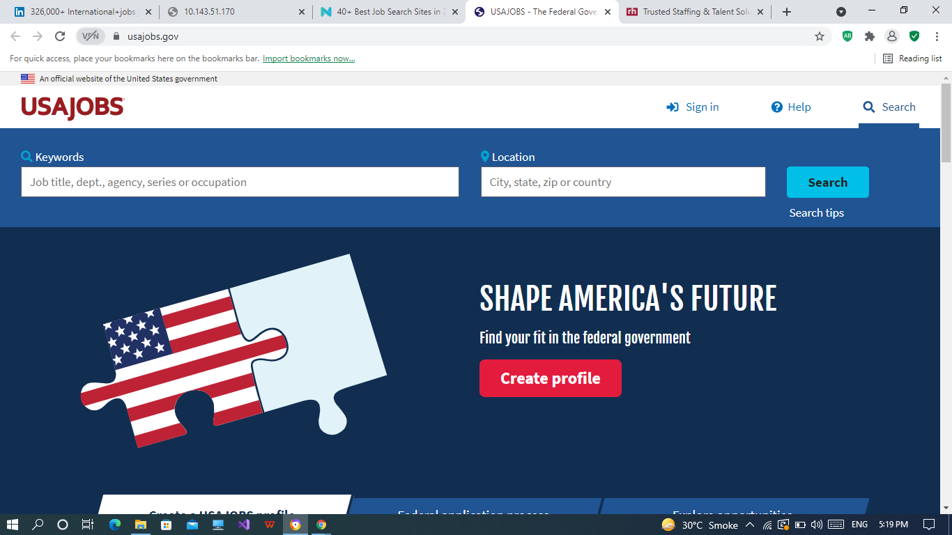

**URL:**

<https://www.usajobs.gov/>

**About Us:**

*Looking for a federal position in the U.S. government?*

[USAJOBS](https://www.usajobs.gov/" \t "_blank) is an official website of the U.S. government for those *specifically* looking for **government jobs**.

This is as official as it gets, so if you’re serious about your career development within a federal position - *you better bring your A-game*.

**Job:17**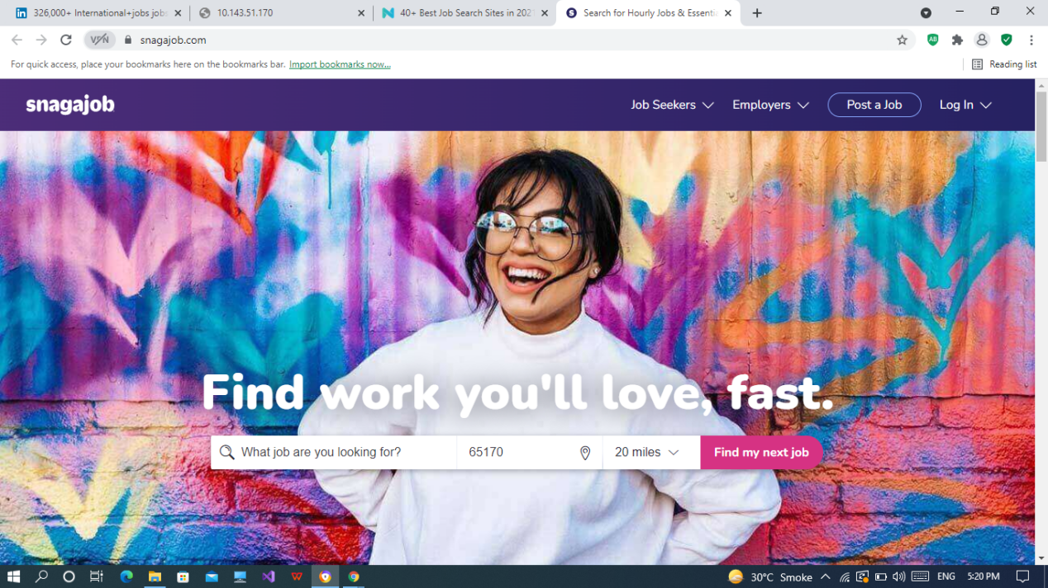

**URL:**

<https://www.snagajob.com/>

**About Us:**

[Snagajob](https://www.snagajob.com/" \t "_blank) is a job search engine that lists job openings *hourly*.

On there, you can find **jobs**, flexible **shifts**, and hourly **insights** on how to succeed in your career.

As an added benefit, you can also download their **app** and be instantly notified whenever there’s a new opening that fits your availability.

**Job:18**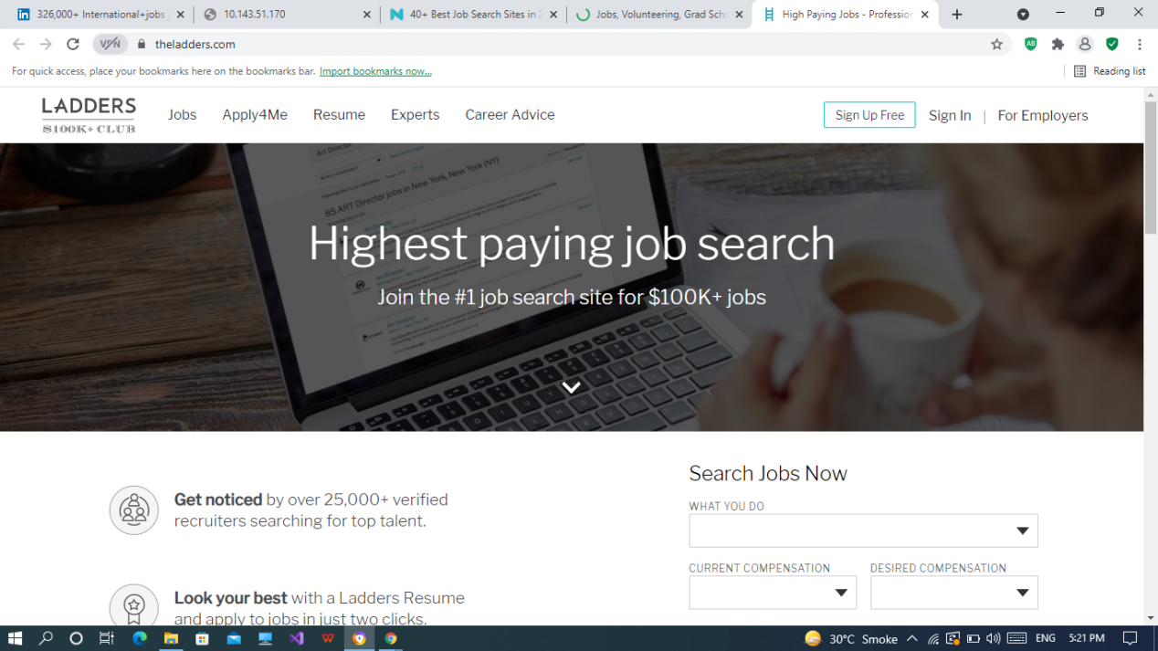

**URL:**

<https://www.theladders.com/>

**About Us:**

[TheLadders](https://www.theladders.com/" \t "_blank) is your one stop shop for all **executive** and **senior-level** jobs.

Candidates looking for positions that pay above six-figure salaries are likely to find this site useful.

If you think you have what it takes and the experience to match your salary, TheLadders is a great site to leap into a senior job role.

**Job:19**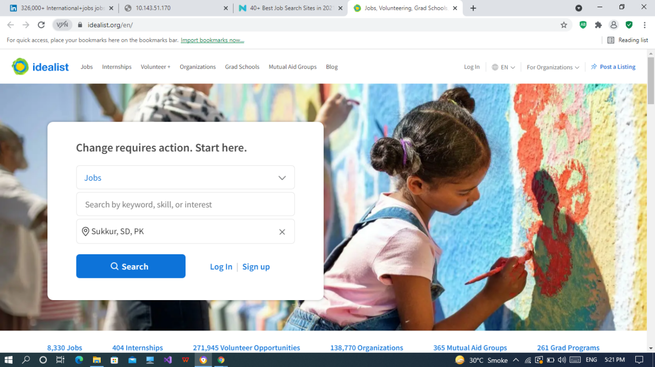

**URL:**

<https://www.idealist.org/en/>

**About Us:**

[Idealist](https://www.idealist.org/" \t "_blank) is the go-to place for all jobs related to the **nonprofit** sector.

This includes **volunteering** positions, **internships**, **grad programs**, **training organizations**, and more.

Once you register, you can start connecting with millions of people who want to *do good* and look for collaboration projects all over the world.

**Job:20**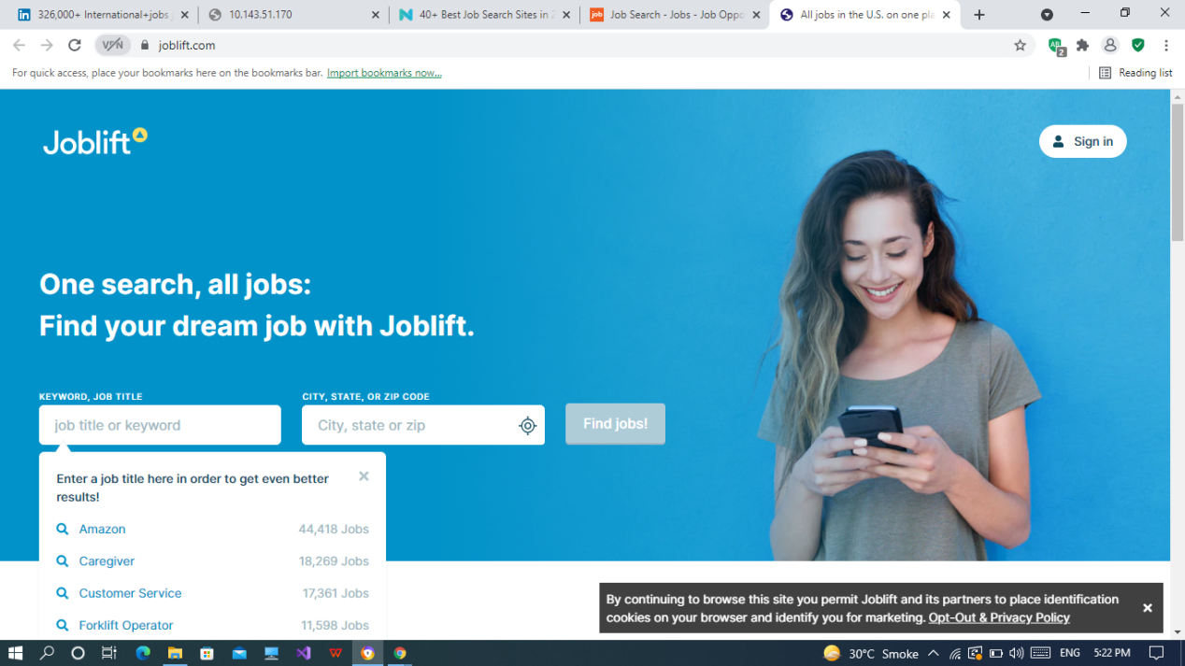

**URL:**

<https://joblift.com/>

**About Us:**

[Joblift](https://joblift.com/" \t "_blank) is an all-in-one approach to a job search website.

All you have to do is a filter for your location and you’ll get a comprehensive list of the entire job market in one platform.

From there on, you can easily start applying for jobs with the site’s easy-to-navigate interface.

**Job:21**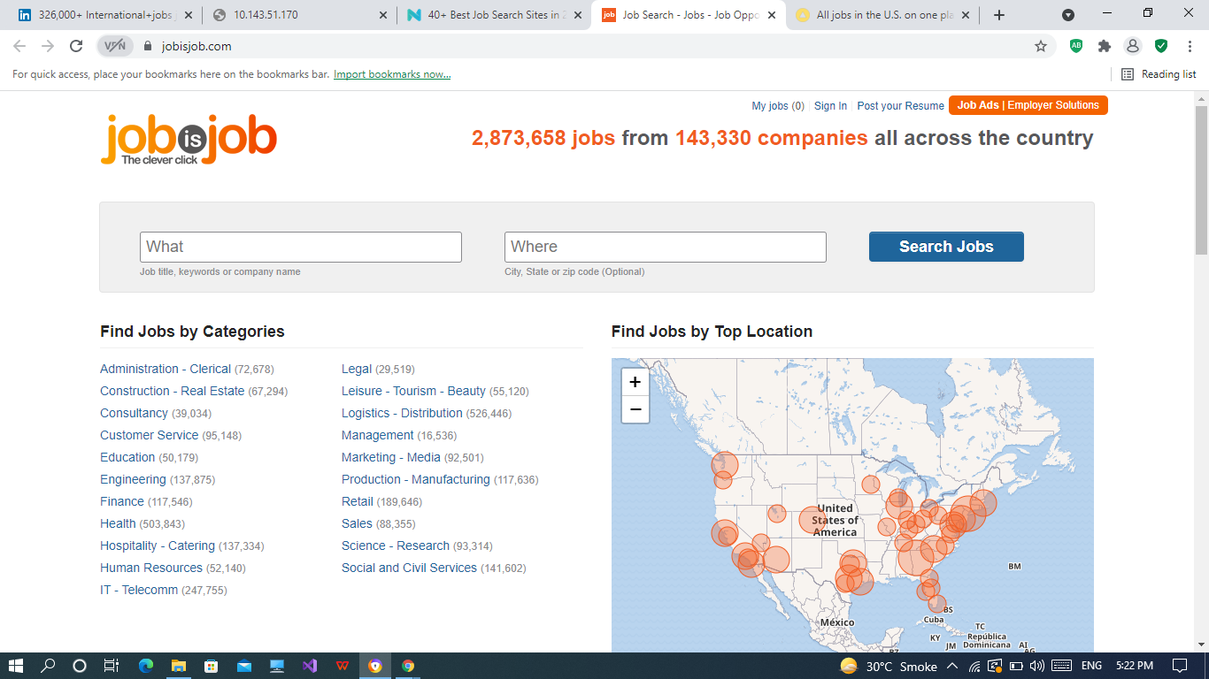

**URL:**

<https://www.jobisjob.com/>

**About Us:**

[JobisJob](https://www.jobisjob.com/" \t "_blank) is another job search site with plenty of job listings under each career field.

You can filter for **most searched jobs**, for l**ocation**, **companies**, and more.

It’s a simple site with well over 5,000,000+ job listings for companies across the U.S.

**Job:22**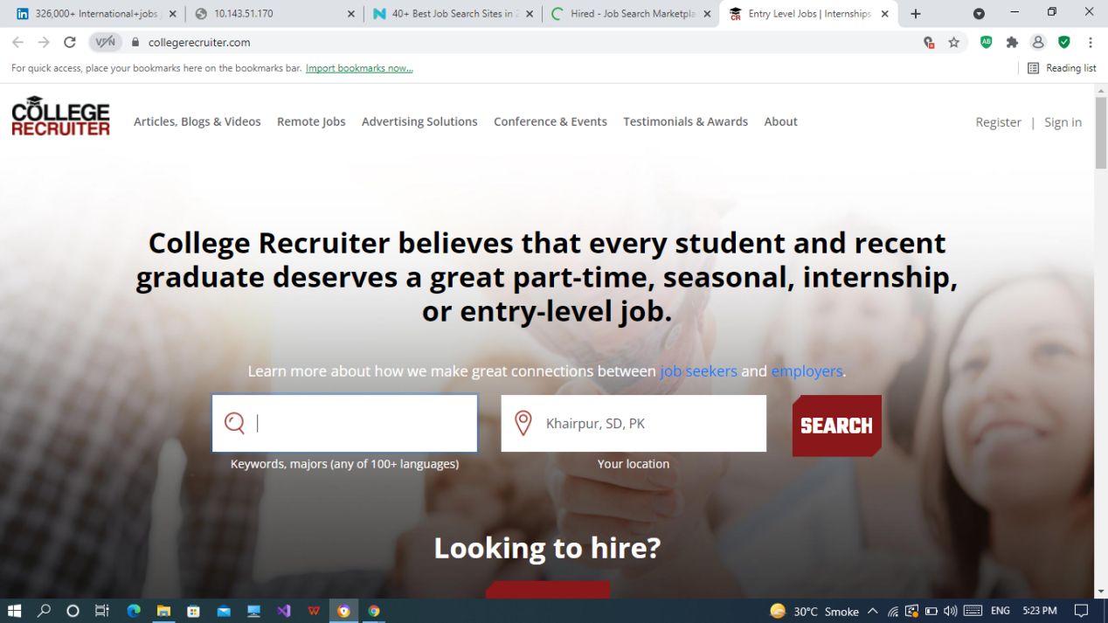

**URL:**

<https://www.collegerecruiter.com/>

**About Us:**

[CollegeRecruiter](https://www.collegerecruiter.com/" \t "_blank) is a job search website for those who don’t have a lot of practical experience under their belt.

Whether you’re looking for an **internship**or an **entry-level job**, this site can help connect you to the right place.

You can filter for jobs based on **your major**, **growing industries**, and/or entry-level **internships**.

**Job:23**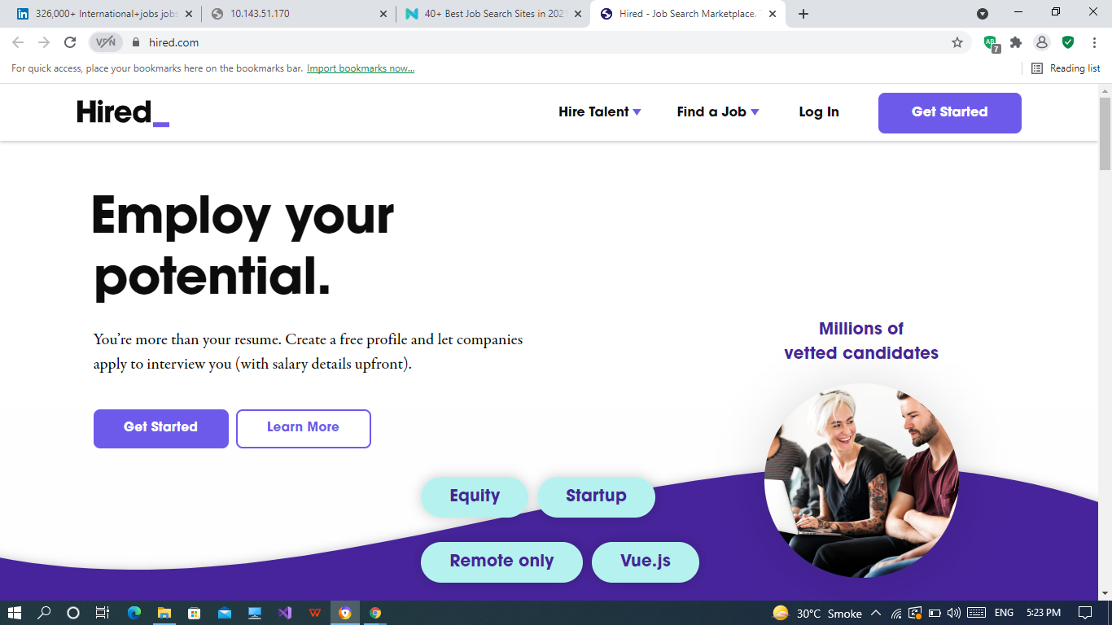

**URL:**

<https://hired.com/>

**About Us:**

[Hired](https://hired.com/" \t "_blank) is a marketplace that matches **tech workers** with innovative IT companies around the world.

The website takes your resume and through its intelligent job matching technology, connects you with companies looking for people with a specific skill set.

Through Hired, you also get the transparency of **salary offers** and other necessary **job details** upfront.

**Job:24**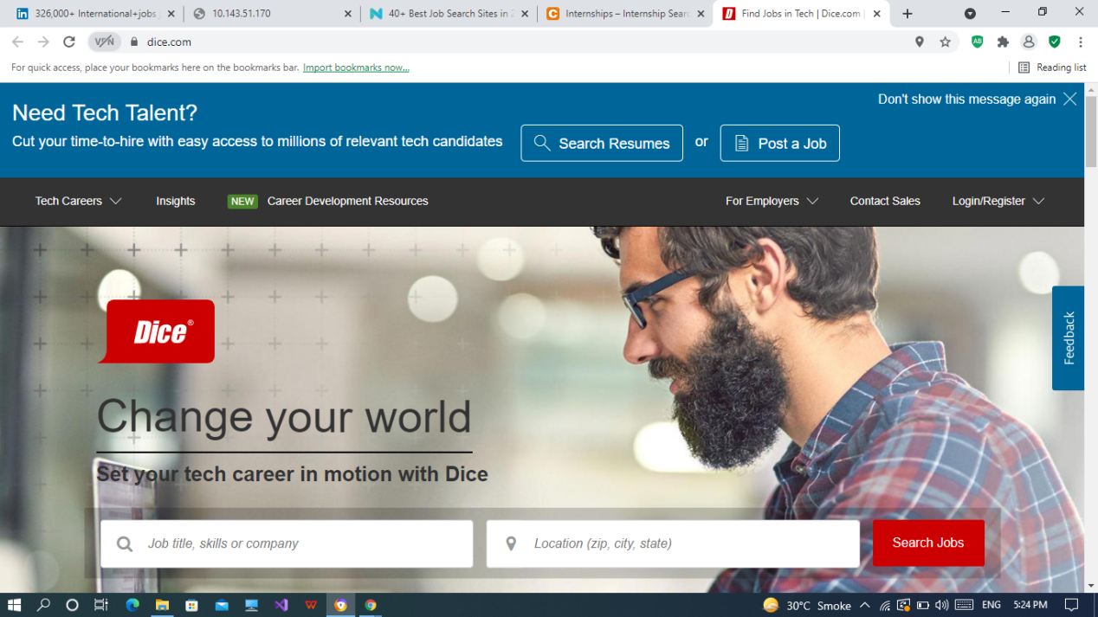

**URL:**

<https://www.dice.com/>

**About Us:**

[Dice](https://www.dice.com/" \t "_blank) is another tech job search site.

It helps you find jobs in some of the top tech corporations and get discovered by top employers by making your profile public.

By signing up, you receive **custom job notifications**, gain the **quick apply** option, and can create **personalized salary estimates**.

**Job:25**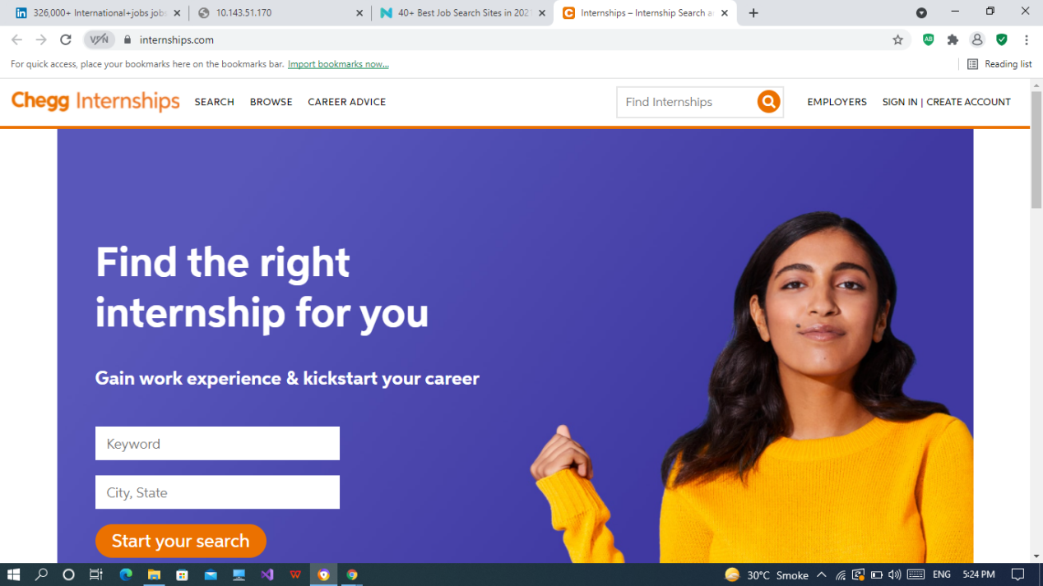

**URL:**

<https://www.internships.com/>

**About Us:**

[Internships](https://www.internships.com/" \t "_blank) is one of the top internship sites within the marketplace.

It features well over 300,000 different kinds of openings - including **entry-level** jobs, **summer opportunities**, **paid** and **unpaid** internships and more. Each separated by the different job categories and majors.

**Job:26**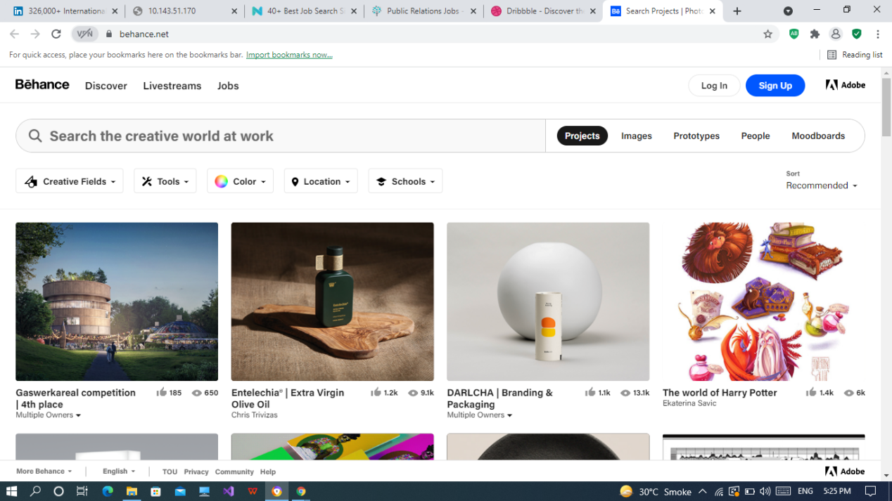

**URL:**

<https://www.behance.net/>

**About Us:**

[Behance](https://www.behance.net/" \t "_blank) is not just a place where graphic designers can show off their portfolios, the website also offers a handy **Jobs section** for all creatives.

Jobs there vary by location and design field (**UX**, **UI**, **product designers**, etc.) and when applying, you can simply upload your portfolio from your Behance profile, making the job application process ten times easier..

**Job:27**

**URL:**

<https://dribbble.com/>

**About Us:**

[Dribble](https://dribbble.com/" \t "_blank) is another site similar to Behance, and like Behance, it also includes a jobs section for all designers.

You can use Dribble to find a mix of **remote** and **in-house** creative jobs all over the world, in all sorts of companies.

**Job:28**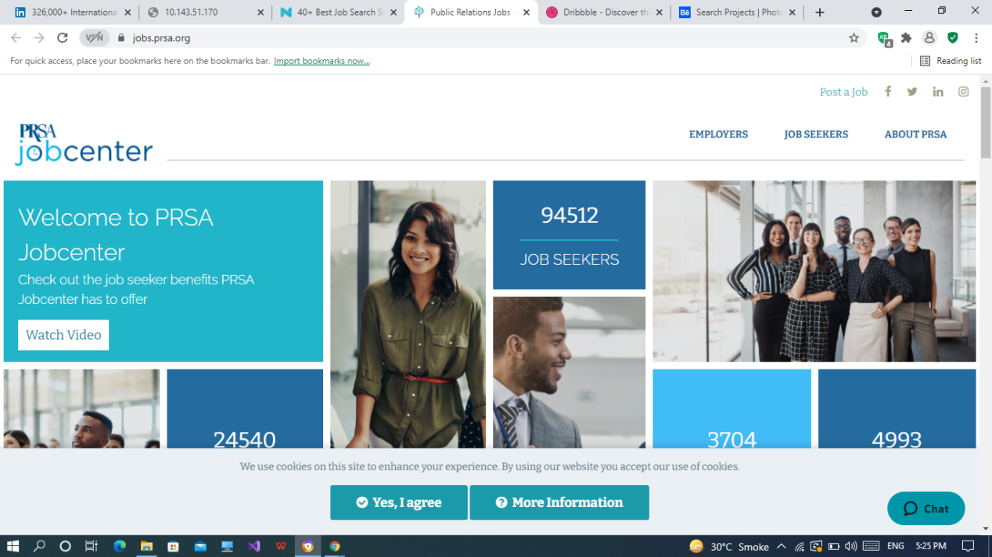

**URL:**

<https://jobs.prsa.org/>

**About Us:**

The [PRSA website](https://jobs.prsa.org/" \t "_blank) acts as a career center for everyone involved in **corporate communications**, **media**, **PR**, and other communication jobs.

Unlike many other professional groups, users don’t have to be a member of the organization to access the job listings.

Everyone can directly apply to the listed positions via email without having to deal with a middleman and will be in touch directly with the recruiters.

**Job:29**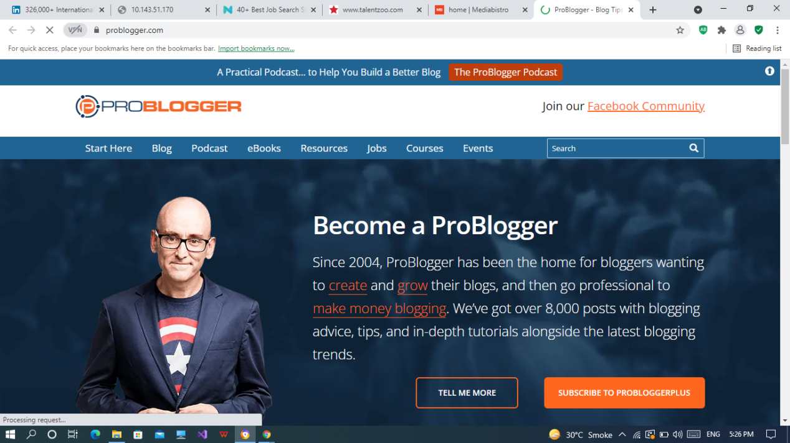

**URL:**

<https://problogger.com/>

**About Us:**

[ProBlogger](https://problogger.com/" \t "_blank), as the name implies, is a home for all sorts of writers (blogs, copy, social media, etc.).

In addition to the job listings, the site has a ton of **resources** for all things writing, applying to jobs safely, online courses, and more.

**Job:30**

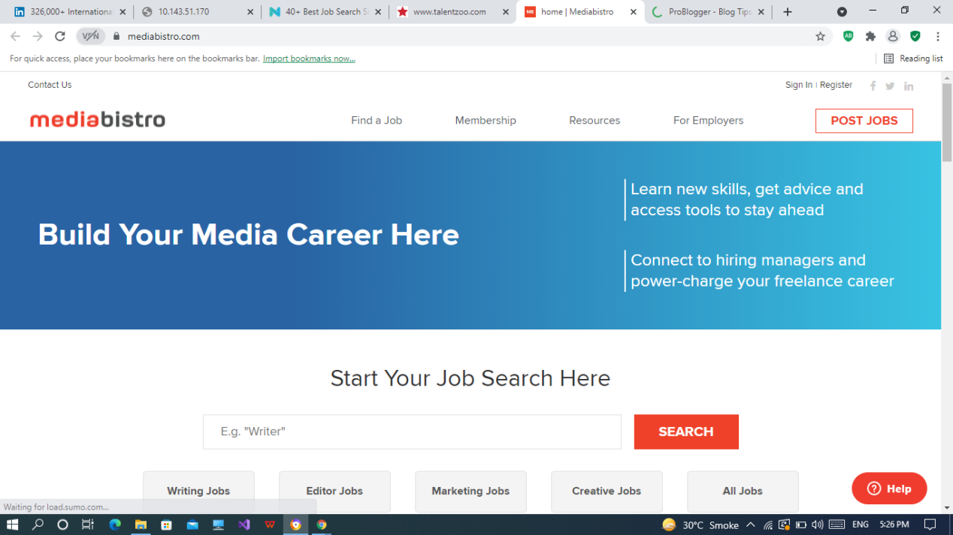

**URL:**

<https://www.mediabistro.com/>

**About Us:**

[MediaBistro](https://www.mediabistro.com/" \t "_blank) is a place to **learn**, **build**, and **grow** your media career.

They offer **courses**, **job openings**, **freelancing opportunities**, and more.

If you work in media or online advertising, chances are, you’re going to find something useful there one way or another.

**Job:31**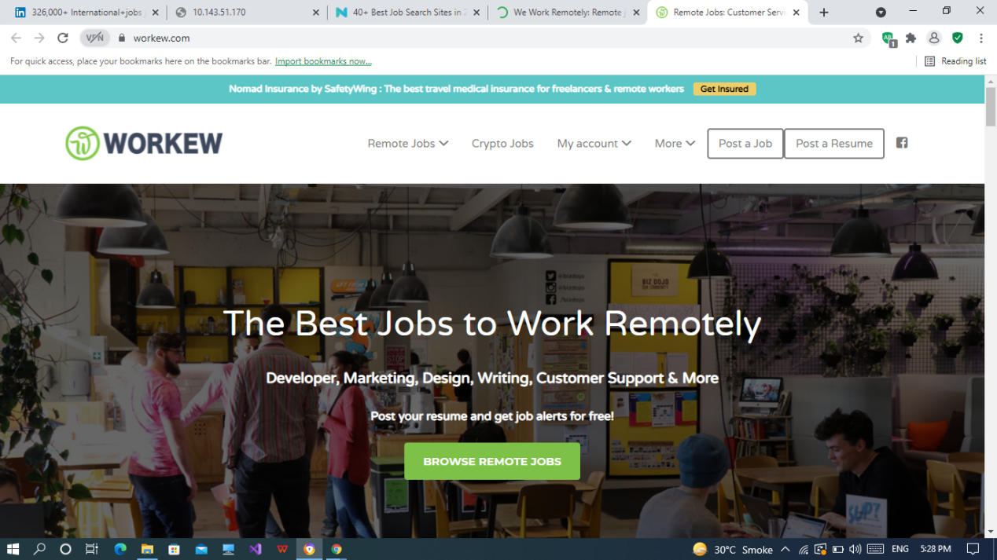

**URL:**

<https://workew.com/>

**About Us:**

[Workew](https://workew.com/" \t "_blank) is a digital nomad’s dream job search site.

You can use the website to find all sorts of remote jobs - mostly in startups and SMBs.

Categories include **marketing**, **development**, **UX and design**, **sales**, **writing**, and much, much more.

**Job:32**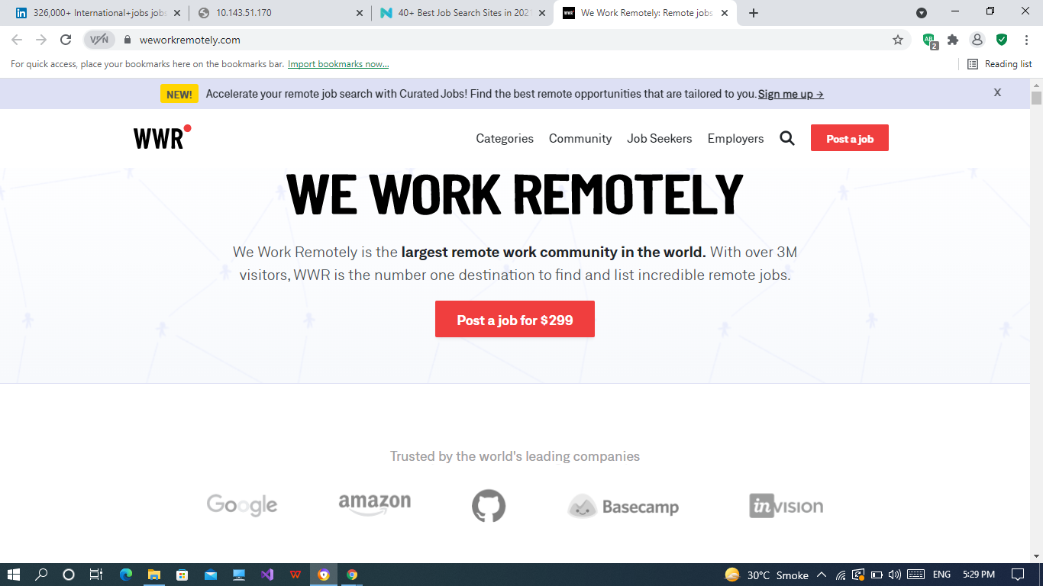

**URL:**

<https://weworkremotely.com/>

**About Us:**

[WeWorkRemotely](https://weworkremotely.com/" \t "_blank) is the world’s largest remote work community website and one of the best places to find remote work.

The website offers remote positions for most fields, including:

* Software Engineering
* Marketing
* Writing
* Editing
* Customer Support

**Job:33**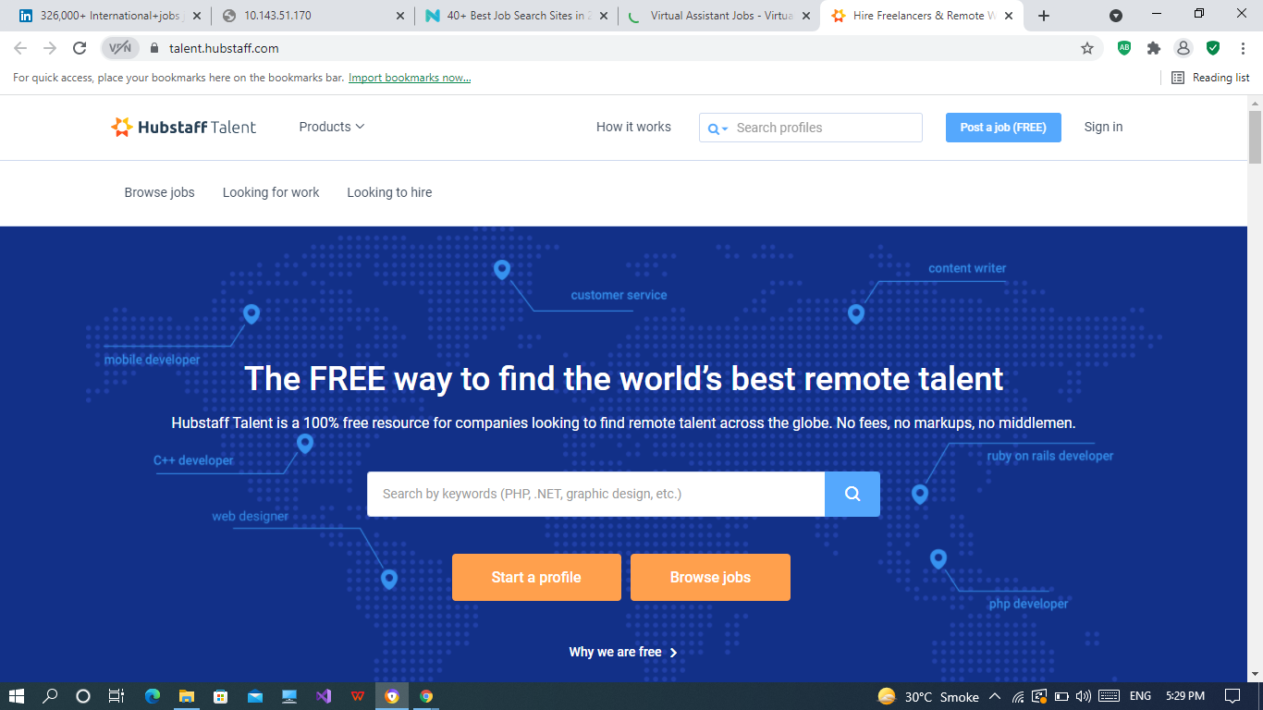

**URL:**

<https://talent.hubstaff.com/>

**About Us:**

[HubStaff Talent](https://talent.hubstaff.com/" \t "_blank) is another free online job board for all things **remote work**.

For freelancers and companies alike, the site is a great resource that lists quality jobs all over the world.

It’s free to get started and has just about any type of job that can be done online.

**Job:34**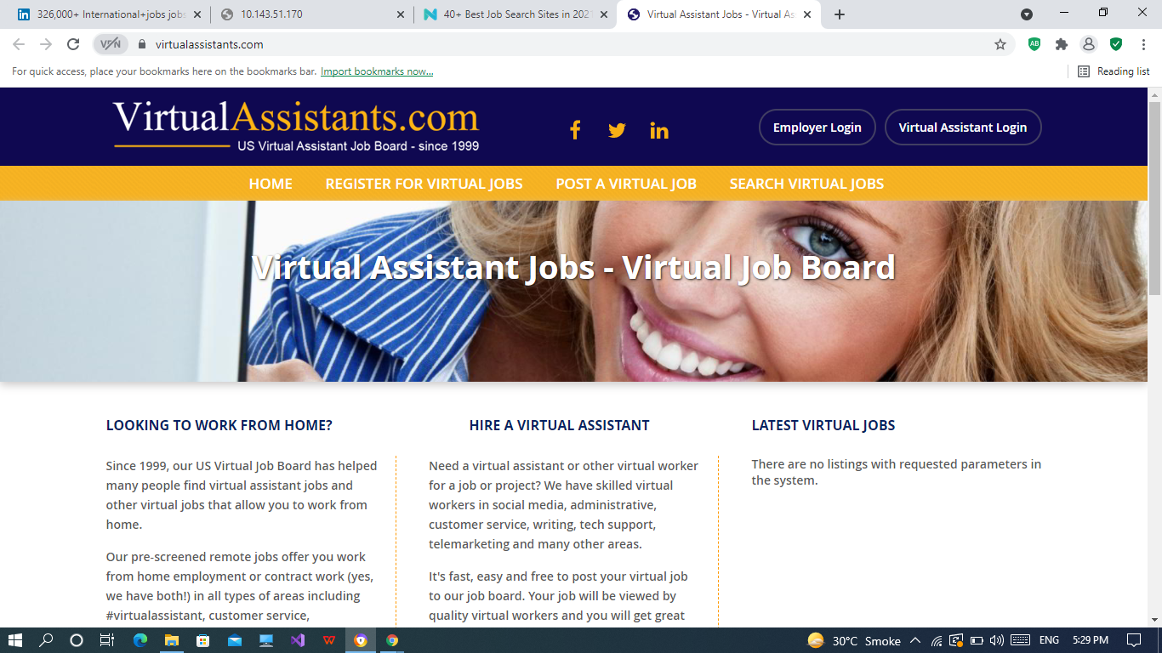

**URL:**

<https://www.virtualassistants.com/>

**About Us:**

[Virtual Assistants](https://www.virtualassistants.com/" \t "_blank) is a U.S. VA job board that has been helping people work from home *since 1999.*

They offer remote jobs that make it possible to work from home through contract work in all types of areas including **customer service**, **telemarketing**, **transcription**, and any other type of **admin task**.

**Job:35**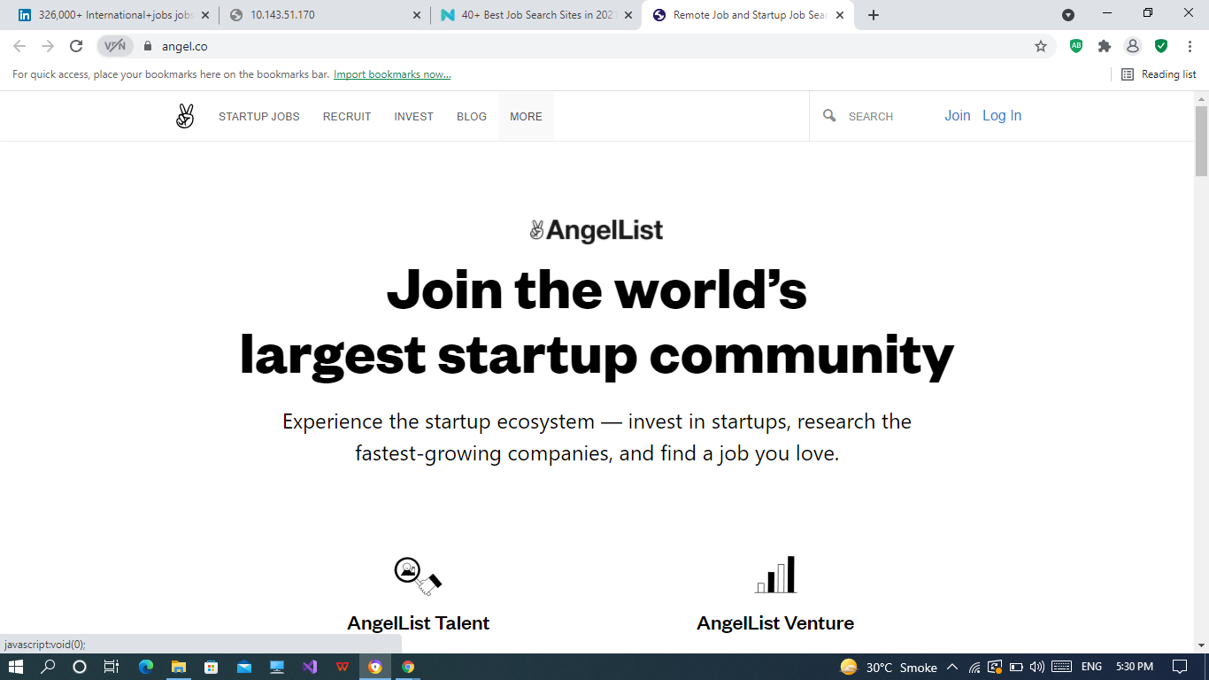

**URL:**

<https://angel.co/>

**About Us:**

[AngelList](https://angel.co/" \t "_blank) is the go-to place for **startup jobs**.

You can **apply privatel**y, see **salary up-front**, and communicate directly to the **startup founders** and **recruiters** posting the ads.

**Job:36**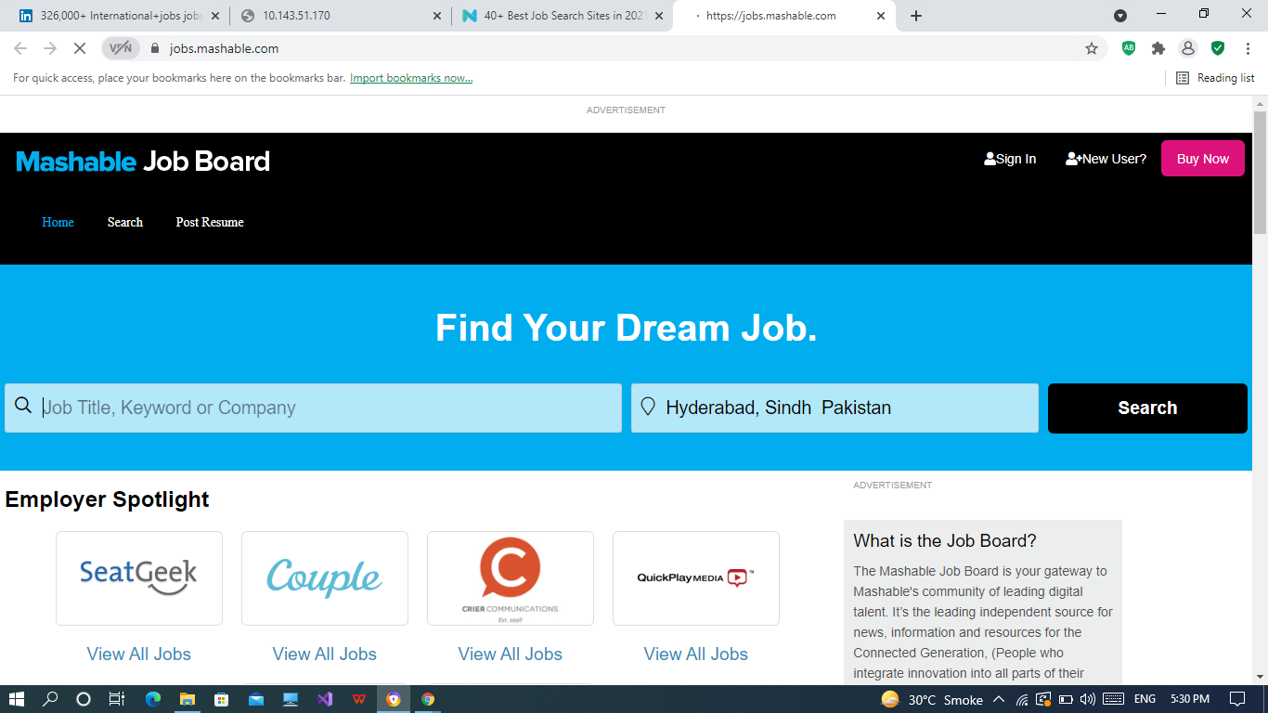

**URL:**

<https://jobs.mashable.com/>

**About Us:**

The [Mashable Job Board](https://jobs.mashable.com/" \t "_blank) is a job search site for all things **digital talent.**

This includes mostly **online jobs** including **advertising**, **design**, **finance**, **IT**, and so on - *remote or otherwise*.

**Job:37**

**URL:**

<https://www.salesgravy.com/>

**About Us:**

[SalesGravy](https://www.salesgravy.com/" \t "_blank) is a job search site for all things, *you guessed it* - **sales**.

Though sales jobs aside, the website also features a ton of resources on sales **trainings**, courses, and any other sales **skills** you’ll need.

**Job:38**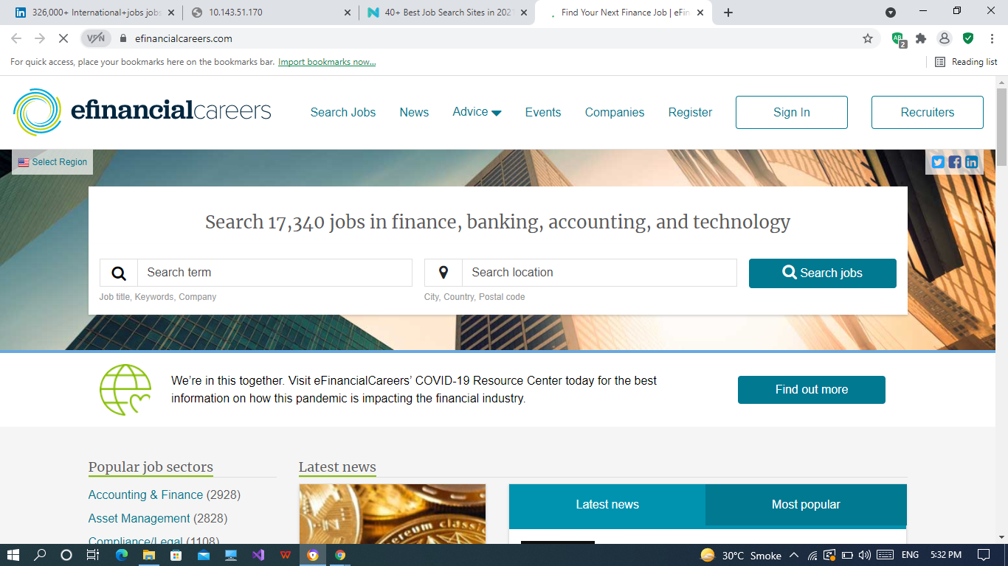

**URL:**

<https://www.efinancialcareers.com/>

**About Us:**

[EFinancialCareers](https://www.efinancialcareers.com/" \t "_blank) lists jobs relating to the finance sector - including **financing**, **banking**, **accounting**, **technology**, and more.

You can create a **profile** and set up **custom notification** alerts, like with many job search sites. And you can also **filter by region** and browse their **career advice** section to help your job search.

**Job:39**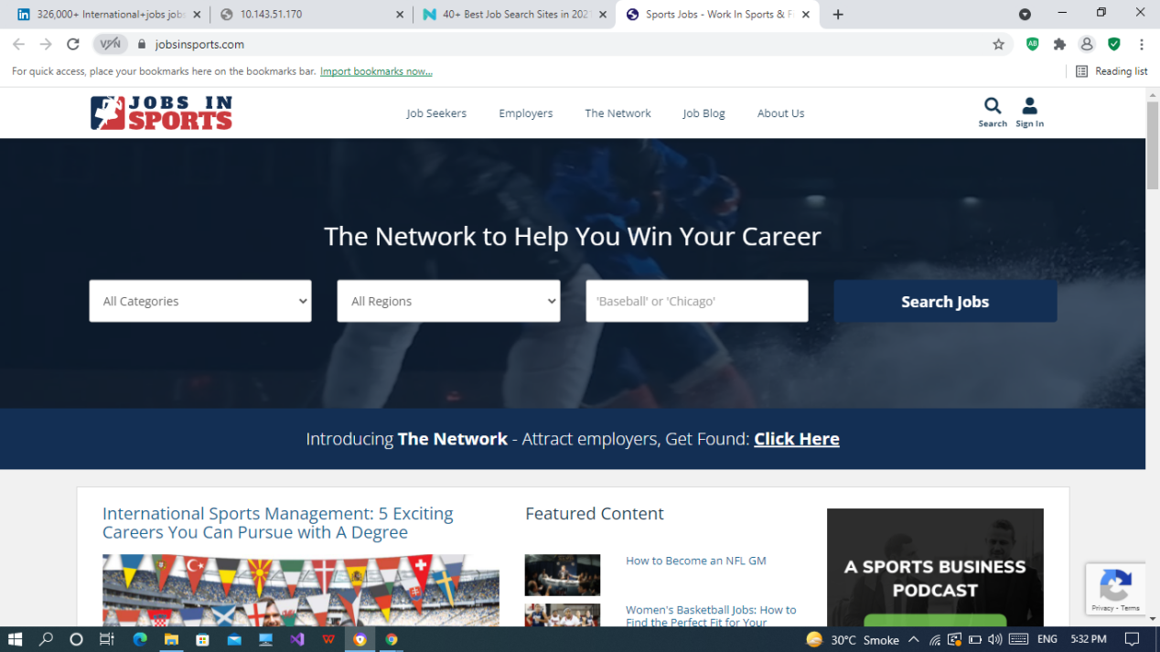

**URL:**

<https://www.jobsinsports.com/>

**About Us:**

[JobsInSport](https://www.jobsinsports.com/" \t "_blank) is *the* most up-to-date job board dedicated to **sports**.

They cover **sports media**, **sales**, **management**, and even more hands-on positions like **coaching**.

**Job:40**

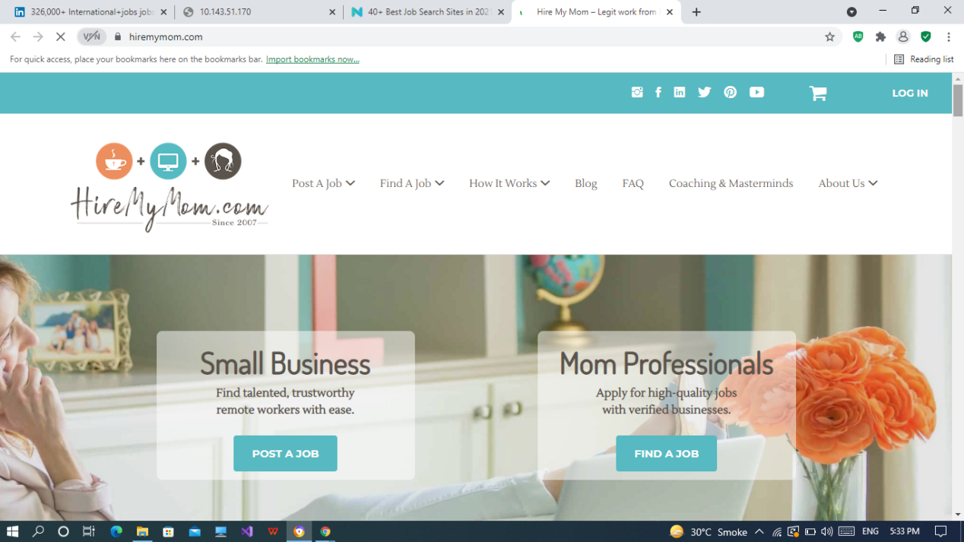

**URL:**

<https://www.hiremymom.com/>

**About Us:**

[HireMyMom](https://www.hiremymom.com/" \t "_blank) is a niche job board for stay-at-home moms or those taking a break from their careers.

The site primarily features jobs that can be done from home. So, roles like **administrative assistant**, **writing**, **marketing**, **virtual assistants**, and more.

**Job:41**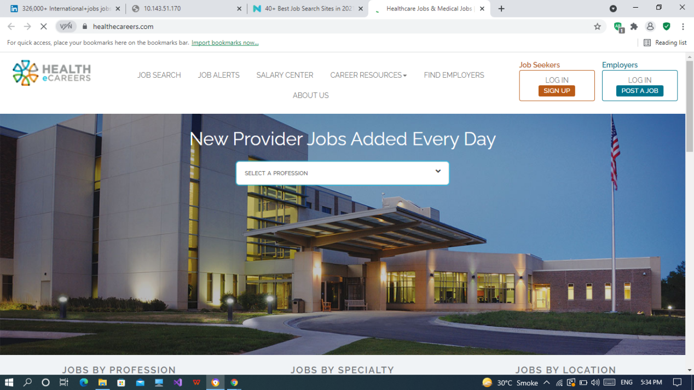

**URL:**

<https://www.healthecareers.com/>

**About Us:**

[Health eCareers](https://healthecareers.com/" \t "_blank) is a job board and organization for everyone working in the healthcare industry.

You can filter for medical jobs by **profession** and **category**, and start looking at listings by major healthcare partners and organizations that are recruiting through the website.

**Job:42**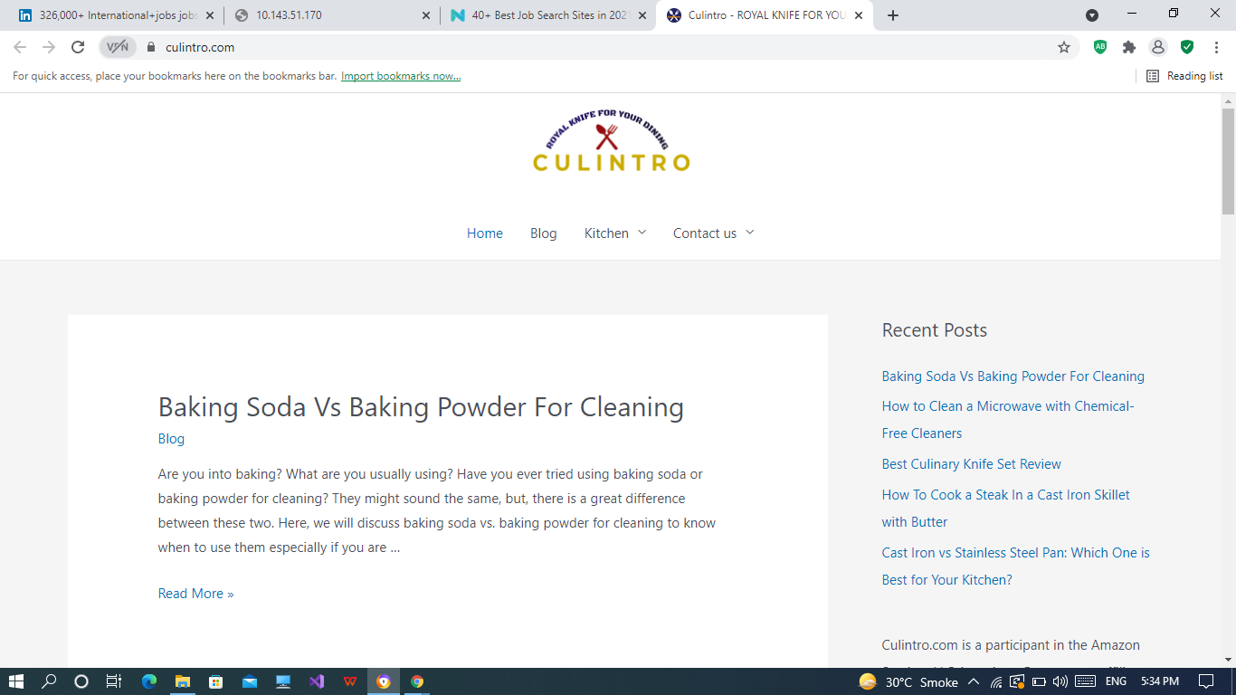

**URL:**

<https://culintro.com/>

**About Us:**

[Culintro](https://culintro.com/" \t "_blank), last but not least, is a job board for the restaurant industry that lists high-end establishment positions like **executive chefs**, **director of dining**, and more.

They have a community of over 65,000 members who are passionate about the industry and the site also offers benefits such as industry **networking events**, **blogs**, and **career advice** within the niche.

**Job:43**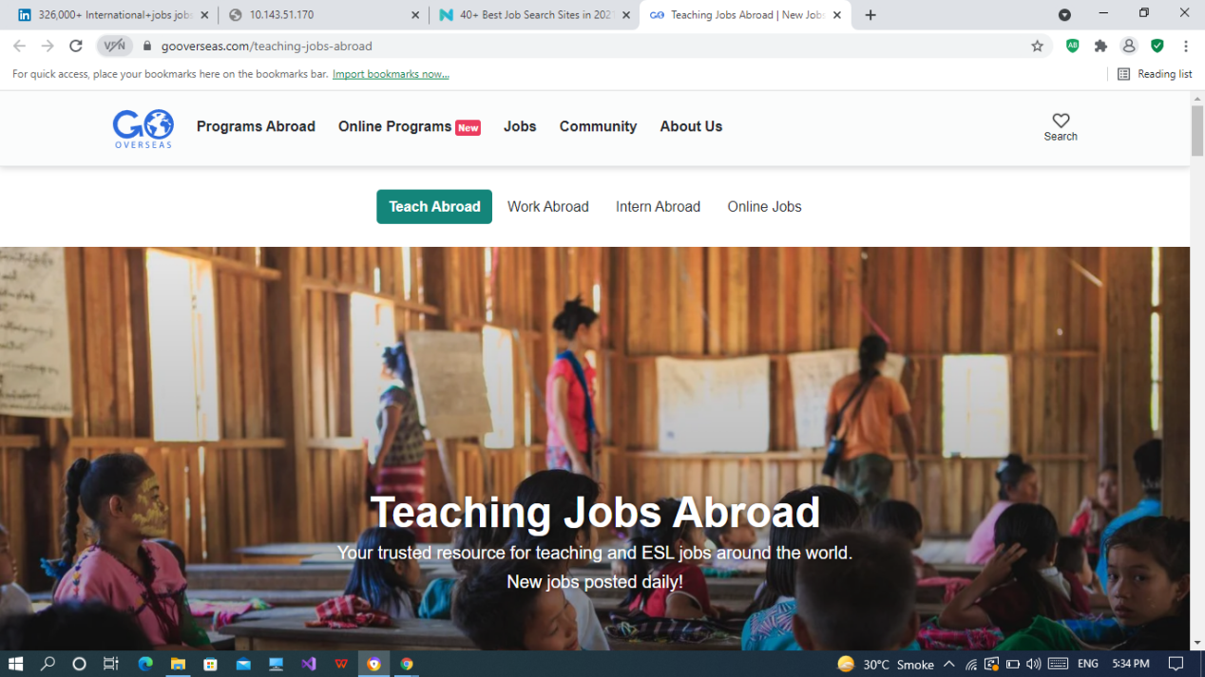

**URL:**

<https://www.gooverseas.com/teaching-jobs-abroad>

**About Us:**

[Go Overseas](https://www.gooverseas.com/teaching-jobs-abroad" \t "_blank) is focused on working overseas with boards for jobs, internships and teaching positions.

**Job:44**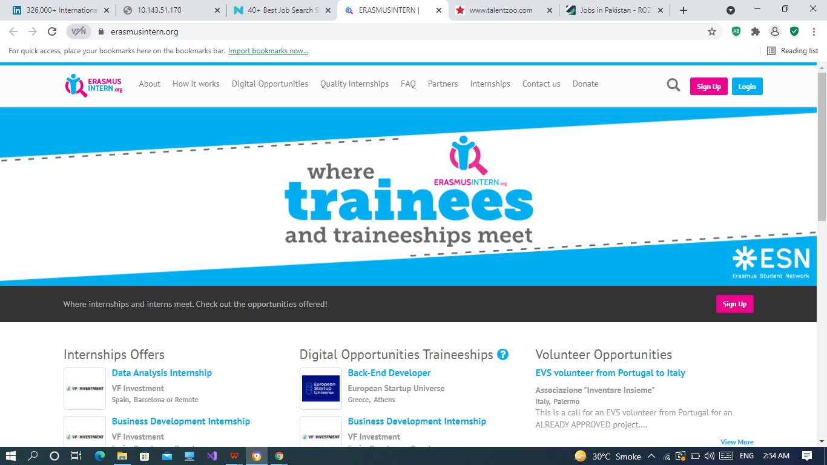

**URL:**

<https://erasmusintern.org/>

**About Us:**

**If you’re still studying or you recently graduated**, [ErasmusIntern](https://erasmusintern.org/" \t "_blank) is a great way to gain practical experience through a hands-on internship.

They offer listings mostly in assistant and trainee roles in a lot of different countries throughout Europe, depending on the field of study or degree.

If you want to break out of your comfort zone and learn a new skill while doing so, ErasmusIntern is the way to go.

**Job:45**

**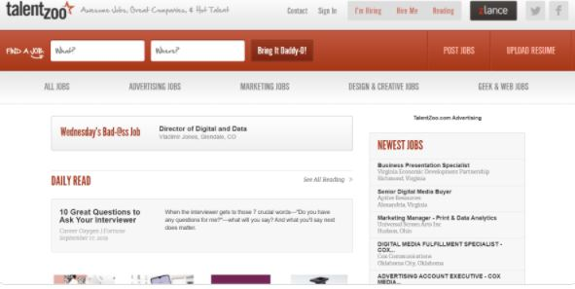**

**URL:**

<http://www.talentzoo.com/>

**About Us:**

[TalentZoo](http://www.talentzoo.com/" \t "_blank) is a job search site for mostly **creative roles**, including **advertising**, marketing, **design** and **creative**, and other online **tech** jobs.

All you have to do is type in your **What** (job role), and **Where** (location) to see a list of openings - *it’s that simple.*

**Job:46**

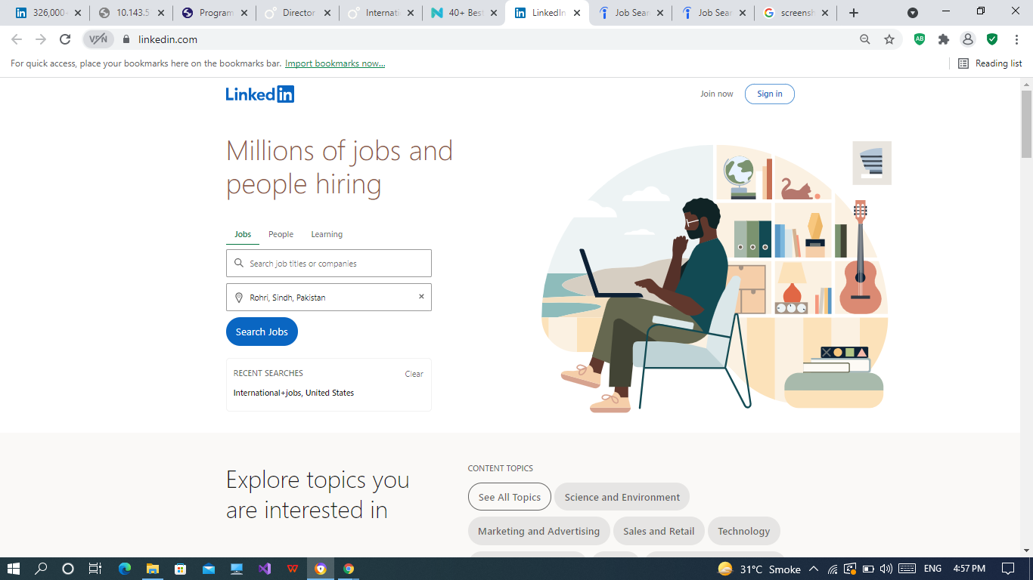

**URL:**

<https://www.linkedin.com../>

**About Us:**

the world's largest professional network with nearly 800 million members in more than 200 countries and territories worldwide.

[LinkedIn](https://www.linkedin.com/" \t "_blank) is another obvious choice, and it is so much more than just a job board.With it, you can search for specific job listings based on **location**, **seniority level**, and more. You can also boost your **networking reach** by connecting with key people in your field.

You can use LinkedIn to land a job in several different ways:

* Getting in touch with recruiters in your industry
* Checking company job openings
* Looking up open positions

Getting head-hunted (if your profile is well-optimized)

**Job:47**

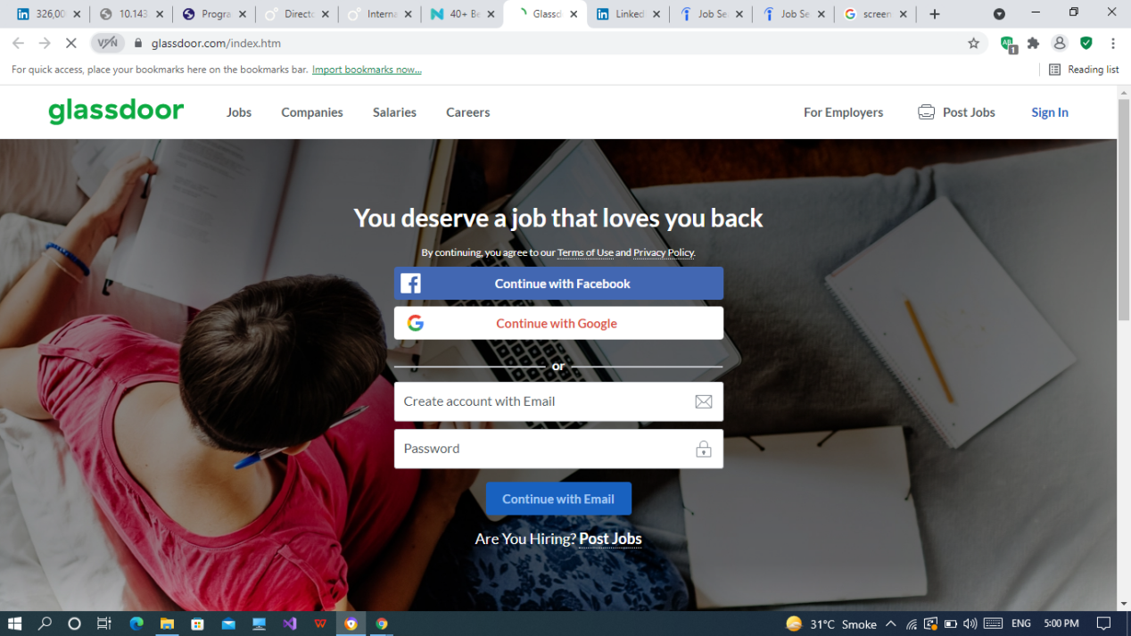

**URL:**

<https://www.glassdoor.com/index.htm/>

**About Us:**

[Glassdoor](https://www.glassdoor.com/" \t "_blank) is a really practical job search website because you can filter your searches based on the **job type**, **salary range**, **distance**, and more.

And if you really want to be on top of your career game, you can use GlassDoor to look up the following:

* Average salaries for your field
* Average salaries at a specific company
* Reviews for potential employers
* Typical interview questions at specific companies
* And more!

**Job:48**

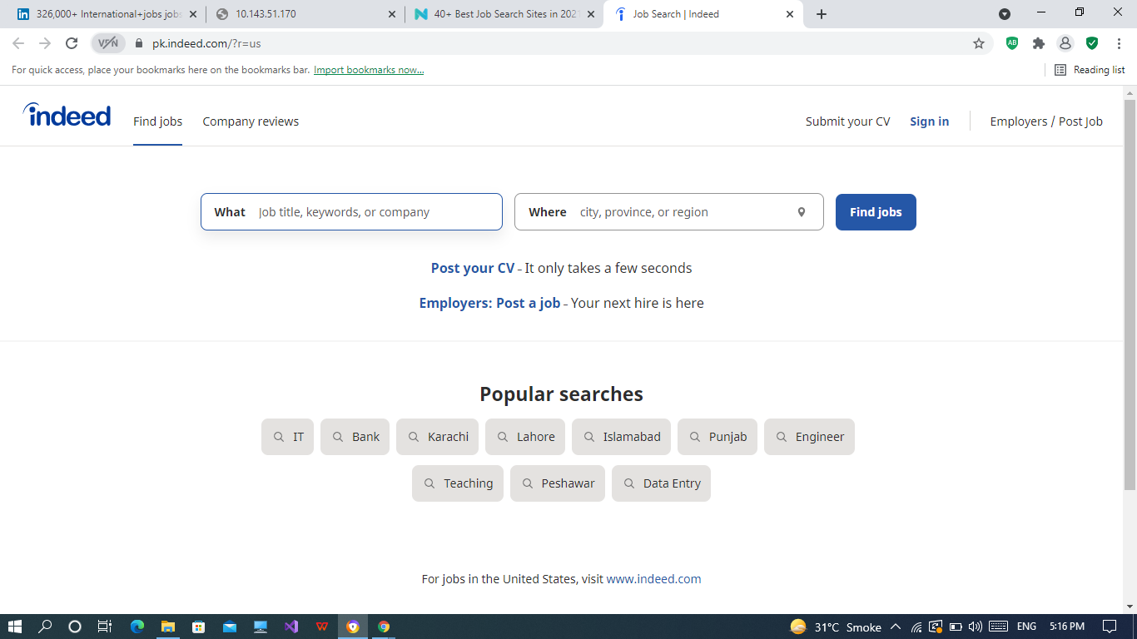

**URL:**

<https://www.indeed.com.pk>

**About Us:**

Indeed is the #1 job site in the world1 with over 250 million unique visitors2 every month. Indeed strives to put job seekers first, giving them free access to search for jobs, post CVs, and research companies. Every day, we connect millions of people to new opportunities.

INDEED is one of the most popular job boards on the internet - you’ve probably heard of it.

What makes it so popular is that all you have to do is type in your **job title keywords** and your **location** on the website. And then, you’ll instantly gain results from thousands of different company career pages.

Though, if you want, you can also create an Indeed **profile** and let employers come to you instead - not bad, right?

**Job:49**

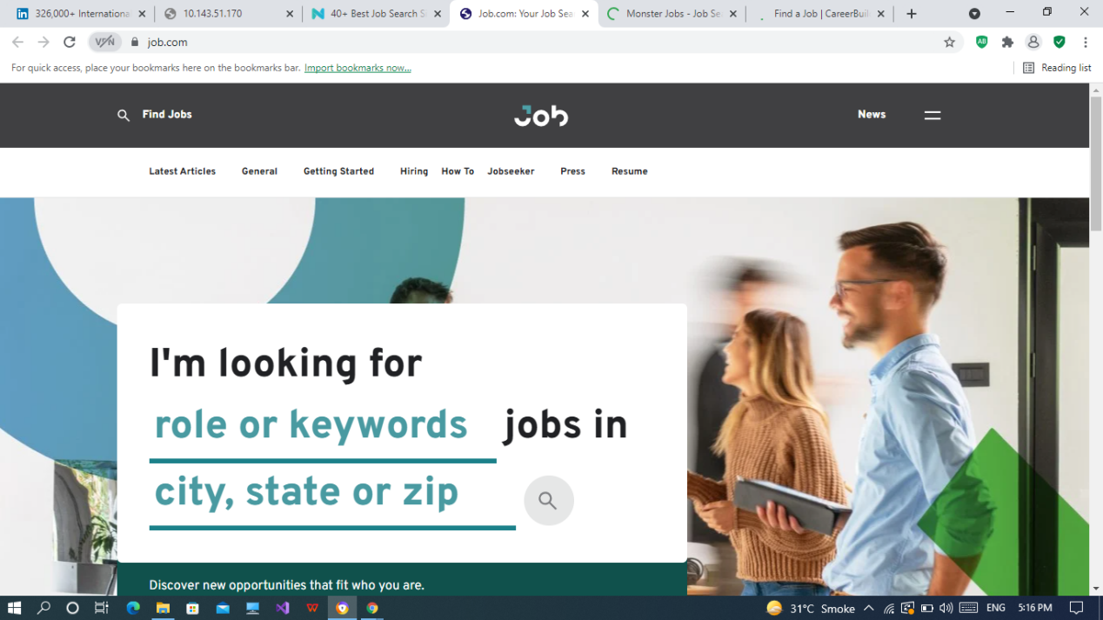

**URL:**

<https://www.job.com/>

**About Us:**

[Job.com](https://www.job.com/" \t "_blank) offers an innovative approach to the job recruitment model by using **artificial intelligence** and **automation**.

All you have to do is upload your resume, and their innovative tech will connect you with new job opportunities on its own - *while giving you feedback at each step of the way.*

As a cherry on top, you also get a 5% signing reward if you get a job using their automated hiring platform.

**Job:50**

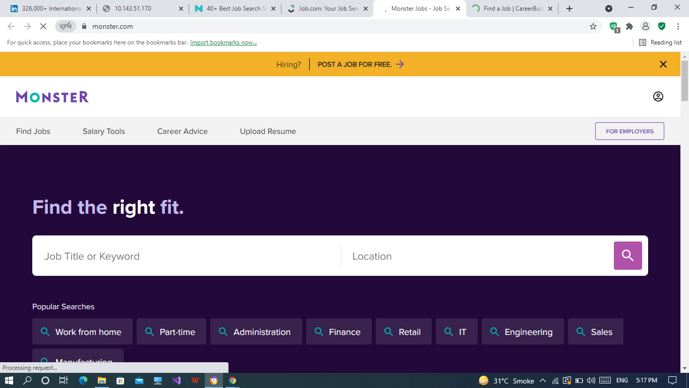

**URL:**

<https://www.monster.com/>

**About Us:**

[Monster](https://www.monster.com/" \t "_blank) is another general job board search site where you can look for jobs based on **keywords**, **location**, - *all the usual stuff.*

The site has a great job selection list and you can also look for jobs based on categories on (e.g. legal, accounting, marketing, etc.).

And finally, what’s really unique about Monster is that the site also has an advice section where you can get career advice based on your application.